**Lab Name: Cursor of Oracle database.**

**Objective**: Learning about Cursor and learn how to implement it.

**What is Cursor?:** The Oracle Engine use a work area for its internal processing in order to execute an SQL Statement. This work area is private to SQL’s operations and is called Cursor.

**Types of Cursors:** Cursors are classified depending on the circumstances under which they are opened. If the Oracle engine opened a cursor for its internal processing it is known as an **Implicit Cursor**.

A Cursor can also be opened for processing data through a PL/SQL block, it is known as **Explicit Cursor**.

**General Cursors attributes:**

|  |  |
| --- | --- |
| Attribute Name | Description |
| %ISOPEN | Returns TRUE if cursor is open, FALSE otherwise. |
| %FOUND | Returns TRUE if record was fetched successfully, FALSE otherwise. |
| %NOTFOUND | Returns TRUE if record was not fetched successfully, FALSE otherwise. |
| %ROWCOUNT | Returns number of records processed from the cursor. |

**Example:** There is a table named student. Using cursor I am taking ID as user input and updating Name of that ID. If the required row is found then it will be updated and show a messages “Name successfully updated”. If the ID is not found then it will be show a messages that “id not found”

**Table name:** student

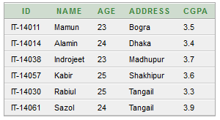

**SQL for using Cursor:**

DECLARE

newName varchar2(25);

studentid varchar2(8);

BEGIN

newName:=:newName;

studentId:=:studentId;

UPDATE student SET name=newName WHERE id=studentid;

IF SQL%FOUND THEN

dbms_output.put_line('Name successfully updated');

END IF;

IF SQL%NOTFOUND THEN

dbms_output.put_line('id not found');

END IF;

END;

**Output:**

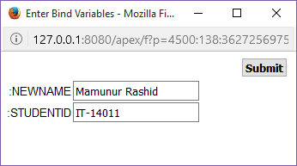

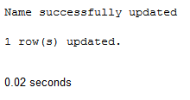

**Now the student table is**:

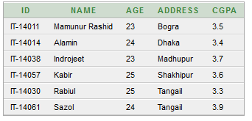

**If the id is not in the table then the output is:**

